EX No:1 | EDA-DATA CLEANING
Date:

Aim:
To perform Exploratory Data Analysis (EDA) and data cleaning on the Sleep Health and Lifestyle dataset using standard data science frameworks (CRISP-DM, SEMMA, and KDD) by handling missing values, removing duplicates, and analyzing sleep and lifestyle patterns.
Algorithm:
- Import pandas, numpy, and matplotlib.pyplot.
- Load the Sleep Health and Lifestyle dataset and inspect its structure, missing values, and duplicate records.
- Clean the data by removing duplicate records and handling missing values in the Sleep Disorder column.
- Check and prepare the dataset attributes for analysis.
- Analyze frequency distributions of key variables and examine relationships between numerical variables using a correlation matrix.
- Summarize the identified sleep health and lifestyle patterns and complete the execution.

Program:
import pandas as pd
import numpy as np
import matplotlib.pyplot as plt

CRISP-DM FRAMEWORK
#1. BUSINESS UNDERSTANDING
Objective:
Analyze sleep patterns, sleep quality, lifestyle factors, stress levels, and sleep disorders.
You can keep the rest of the CRISP-DM structure exactly as in the document.

# 2. DATA UNDERSTANDING

df = pd.read_csv(r"C:\Users\SHREYA\Downloads\Sleep_health_and_lifestyle_dataset.csv")
print(df.head())
print("Dataset Shape:")
print(df.shape)
print("\nDataset Information:")
print(df.info())
print("\nStatistical Summary:")
print(df.describe())
print("\nMissing Values:")
print(df.isnull().sum())
print("\nDuplicate Records:")
print(df.duplicated().sum())

# 3. DATA PREPARATION

df.drop_duplicates(inplace=True)
df['Sleep Disorder'] = df['Sleep Disorder'].fillna('None')
print("Data preparation completed successfully.")
print("\nMissing Values After Cleaning:")
print(df.isnull().sum())

# 4. MODELING (EDA)

df['Gender'].value_counts().plot(kind='bar')
plt.title("Gender")
plt.show()
df['Sleep Disorder'].value_counts().plot(kind='bar')
plt.title("Sleep Disorder")
plt.show()
df['Occupation'].value_counts().plot(kind='bar')
plt.title("Occupation")
plt.show()
df['BMI Category'].value_counts().plot(kind='bar')
plt.title("BMI Category")
plt.show()
corr = df.select_dtypes(include='number').corr()
plt.figure(figsize=(10,8))
plt.imshow(corr)
plt.colorbar()
plt.xticks(
range(len(corr.columns)),
corr.columns,
rotation=90
)
plt.yticks(
range(len(corr.columns)),
corr.columns
)
plt.title("Correlation Heatmap")
plt.show()

# 5. EVALUATION
print("Business insights generated successfully.")

# 6. DEPLOYMENT
print("Insights can be deployed through dashboards.")

# SEMMA FRAMEWORK
# ============================================================

# SAMPLE
df = pd.read_csv(r"C:\Users\SHREYA\Downloads\Sleep_health_and_lifestyle_dataset.csv")

# EXPLORE

print(df.head())
print(df.info())
print(df.describe())
print(df.isnull().sum())

# MODIFY
df.drop_duplicates(inplace=True)
df['Sleep Disorder'] = df['Sleep Disorder'].fillna('None')

# MODEL

print("EDA patterns and trends identified successfully.")

# ASSESS

print("Patterns and trends successfully identified.")

# KDD FRAMEWORK
# ============================================================

# SELECTION

df = pd.read_csv(r"C:\Users\SHREYA\Downloads\Sleep_health_and_lifestyle_dataset.csv")

# PREPROCESSING

print(df.info())
print(df.isnull().sum())
print(df.duplicated().sum())
df.drop_duplicates(inplace=True)
df['Sleep Disorder'] = df['Sleep Disorder'].fillna('None')

# TRANSFORMATION

df['Sleep Duration'] = pd.to_numeric(df['Sleep Duration'], errors='coerce')

# DATA MINING

print("Data mining completed successfully.")

# INTERPRETATION

print("Knowledge discovered from the dataset has been interpreted to support hotel business decisions.")
Output:
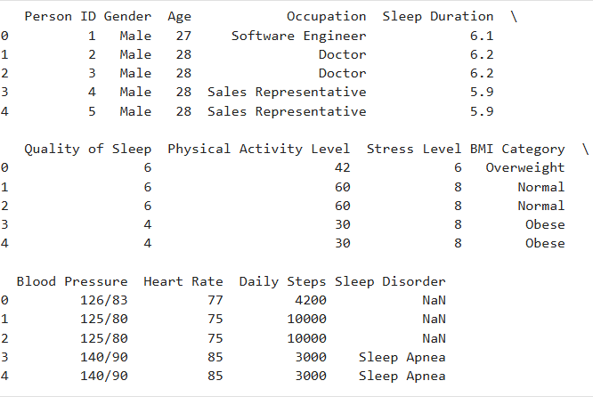

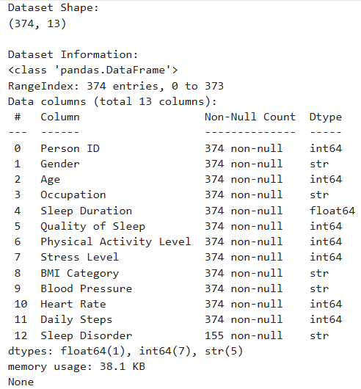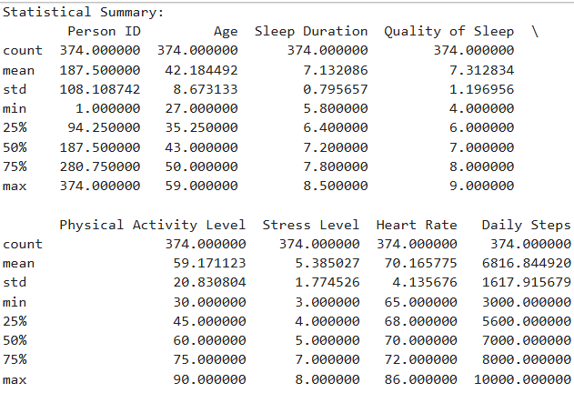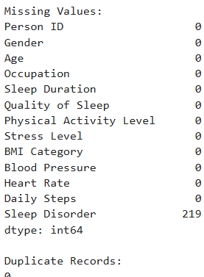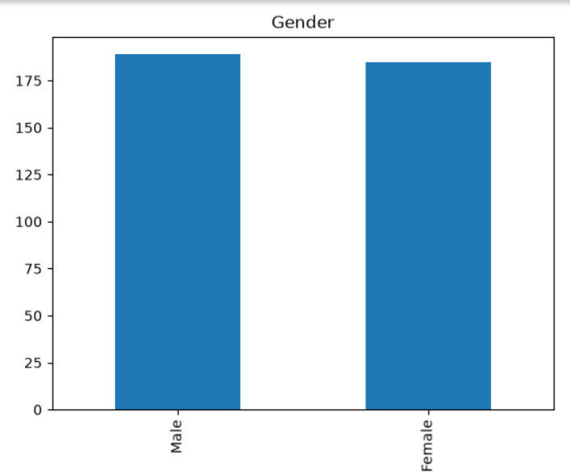
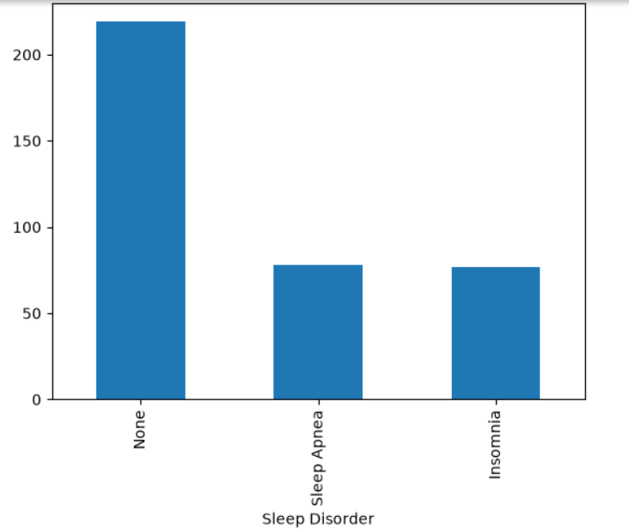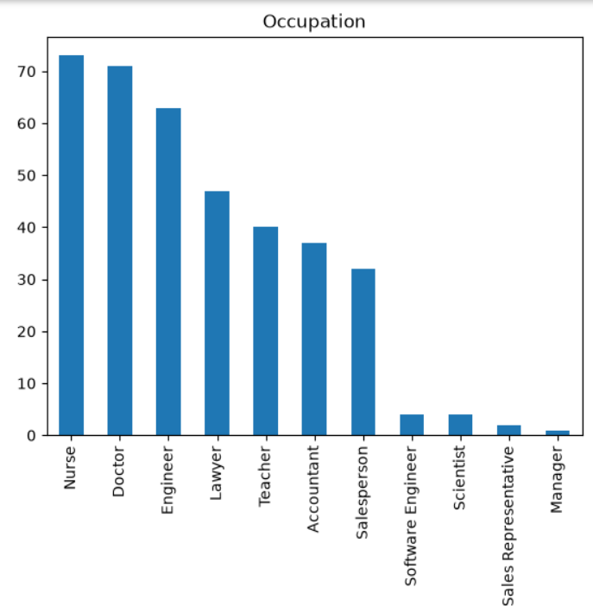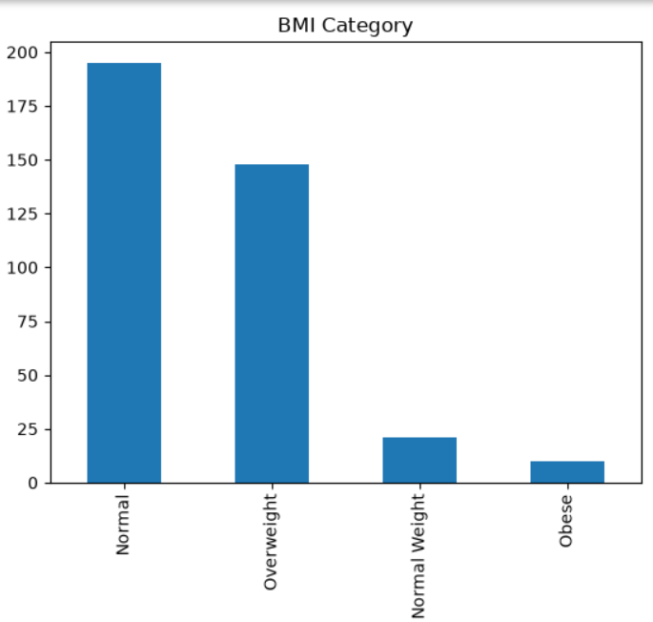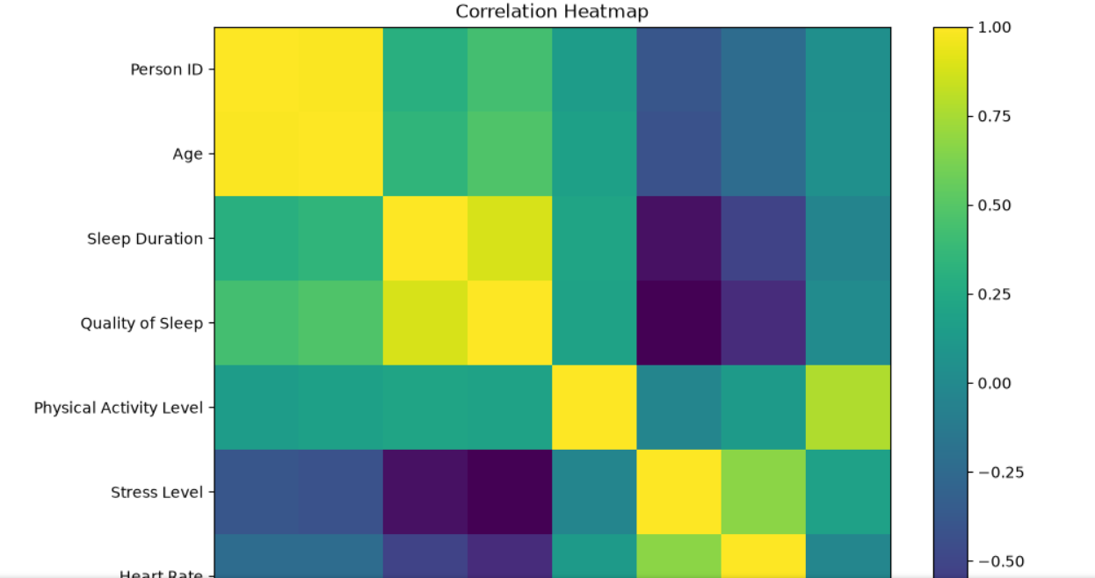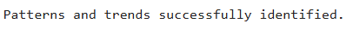
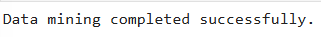

Result:

